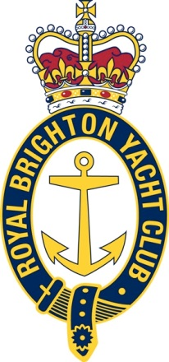
Sailing Administrator

Permanent Part Time (0.8)

Salary $50K FTE

- Leading yacht club with an extensive racing program
- Strong organisational focus within a small hard-working team
- Career enhancing role

This is a hands-on part time role within the Sailing Office at Royal Brighton Yacht Club.

The role involves:
- Sailing program administration including online entry and results systems
- Event administration – regattas and non-sailing events
- Volunteer coordination and support

Key skills include:
- Verbal and written communication
- Computer skills and familiarity with web-based systems
- Methodical with good attention to detail

Reporting directly to the Sailing Manager, you will work in a team which includes club officials, staff and volunteers. You will be instrumental in the organisation and promotion of sailing and racing programs, delivering a busy year round schedule of sailing activities. Your regular workweek will be flexible and will include weekend days. Time in lieu will be given for irregular hours.

Experience in similar roles within sailing would be an advantage, but is not essential.
To express your interest, forward your CV along with a detailed cover letter to Eric Wegman, General Manager at recruitment@rbyc.org.au. Applications close November 13, 2015.

Eric Wegman
General Manager

