Australian Sailing – Victoria News Items Template
To be featured on the website www.yachtingvictoria.com.au
Please send your template to Gavin.Wall@sailing.org.au, Paul.Tweddell@sailing.org.au or Sue.Phillips@sailing.org.au
Key Points to help you write your article:
- Title – The title need to be short and sharp and draw in the reader (ie not more than 10 words).
- Body – Please remember to include
  - Who – What audience was participating in this event, how many people etc
  - What – What is the event and what’s it’s purpose
  - When – When does/ did the event take place
  - Where – Which Club was hosting this event/ where did the event take place?
  - Why – What was the purpose of this event, short term? Long term?
  - How – How do people find more information or register for this event? (URLs)
- Pictures –
  - Regattas – Please use action photos of people sailing
  - Functions – Please use people posing for a photo (not just a general crowd shot)
  - Events – Please include a JPEG of your event poster
Please delete highlighted area and insert your own information.
Title:
Volunteer at the Sailing World Cup Melbourne!
Body: (Information you want the reader to know, please include any relevant links)
Sailing World Cup Final is calling for volunteers to become involved in this year’s event at the St Kilda Sailing Precinct 4th – 11th December 2016. Become involved and experience one of Melbourne's major events!
There are many different roles available both on and off the water to suit all level of skills and abilities. For those with an interest in race management, there is the opportunity to work and learn from some of the best race officers in Australia.
For those who would prefer to remain on-shore there are a number of important roles available where volunteers meet and work with the athletes as well as the current and future Olympians. These roles range from yard management, race officiating, courtesy car drivers, competitor liaison, traffic management, on water blogging and more.
To register as a volunteer for this event click here.
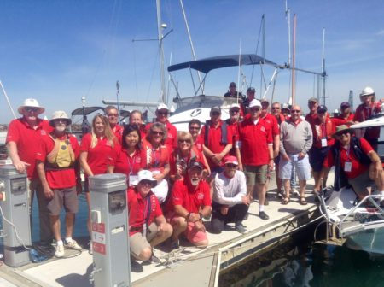
For more information or if you have any questions please email swc@newtack.com.au
We hope to see you there!
IMAGE – copy and paste image below.
Please include credit if required.

